EQUATION OF CIRCLE
Pearson Edexcel – Thursday 4 June 2020 - Paper 2 (Calculator) Higher Tier
1.

Pearson Edexcel - Tuesday 11 June 2019 - Paper 3 (Calculator) Higher Tier
2.
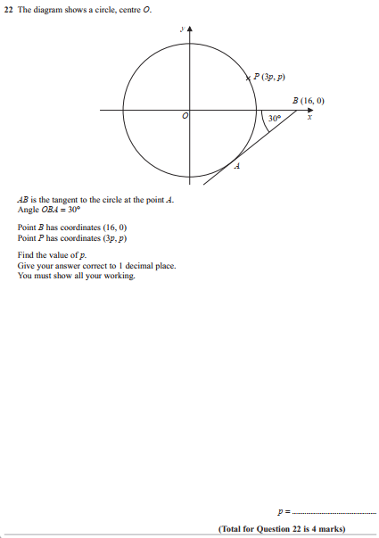
Pearson Edexcel - Thursday 8 November 2018 - Paper 2 (Calculator) Higher Tier
3.
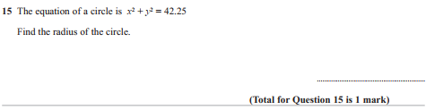
OCR GSCE – Tuesday 3 November 2020 – Paper 4 (Calculator) Higher Tier
4.
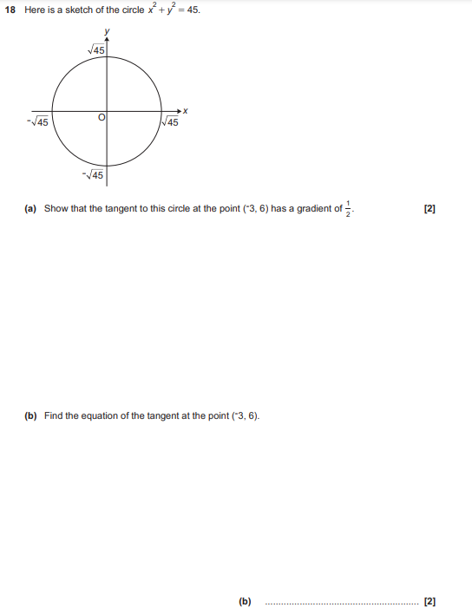

OCR GSCE – Tuesday 5 November 2019 – Paper 4 (Calculator) Higher Tier
5.
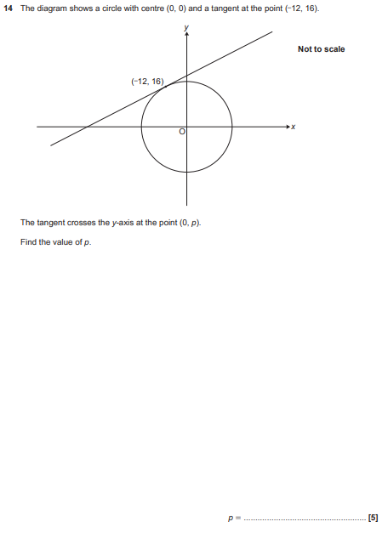

OCR GSCE – Thursday 7 November 2019 – Paper 5 (Non-Calculator) Higher Tier
6.
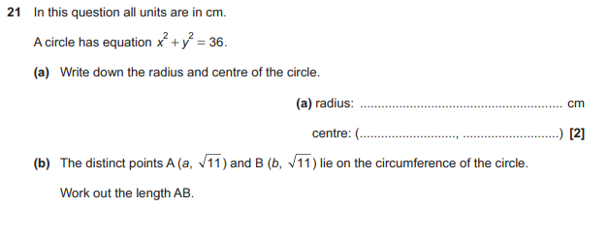

OCR GSCE – Tuesday 11 June 2019 – Paper 6 (Calculator) Higher Tier
7.
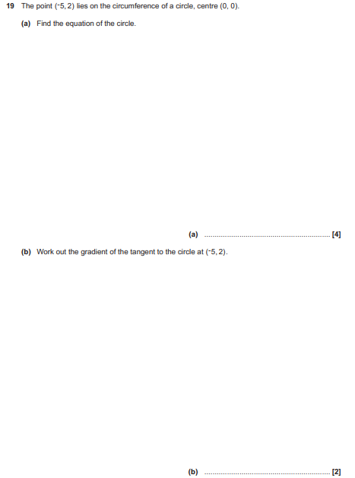

OCR GSCE – Monday 12 November 2018 – Paper 6 (Calculator) Higher Tier
8.
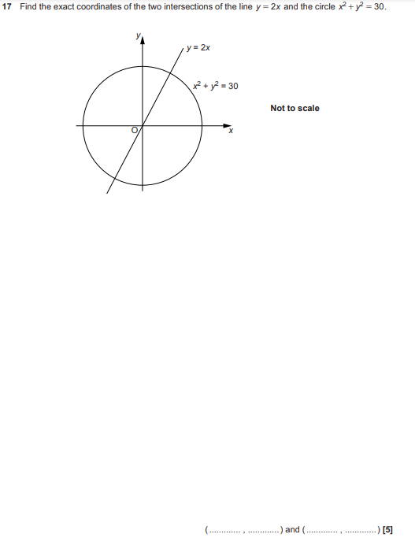

OCR GSCE – Wednesday 8 November 2017 – Paper 6 (Calculator) Higher Tier
9.
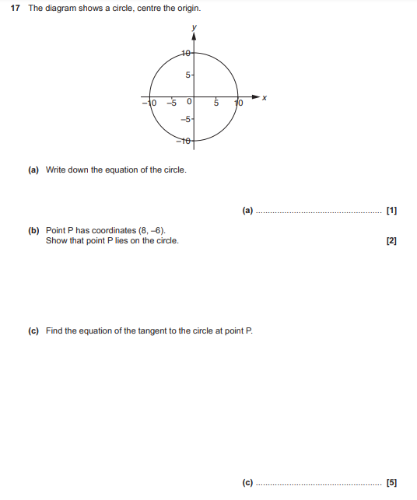
AQA GSCE – Thursday 8 June 2020 – Paper 3 (Calculator) Higher Tier
10.
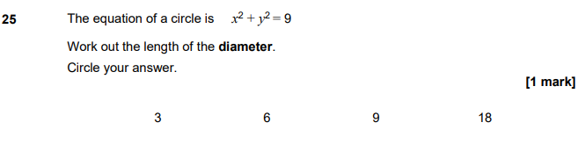
AQA GSCE – Tuesday 11 June 2019 – Paper 3 (Calculator) Higher Tier
11.
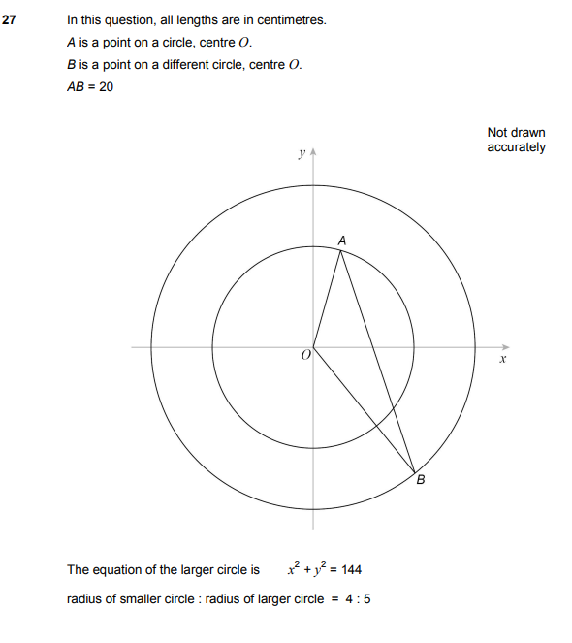
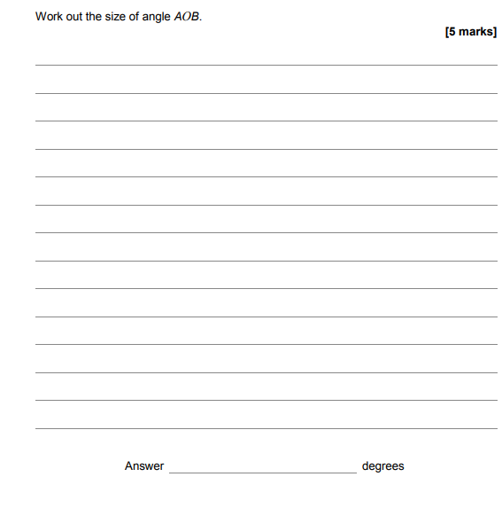

AQA GSCE – Thursday 7 June 2018 – Paper 2 (Calculator) Higher Tier
12.
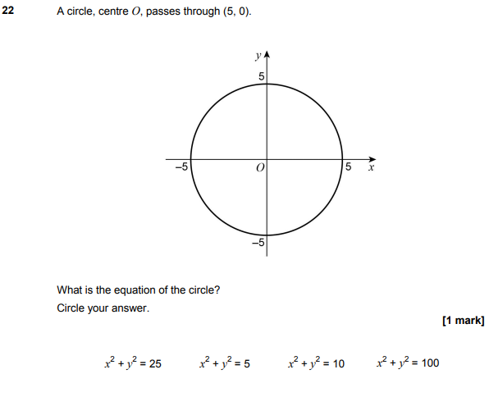

AQA GSCE – Tuesday 12 June 2018 – Paper 3 (Calculator) Higher Tier
13.
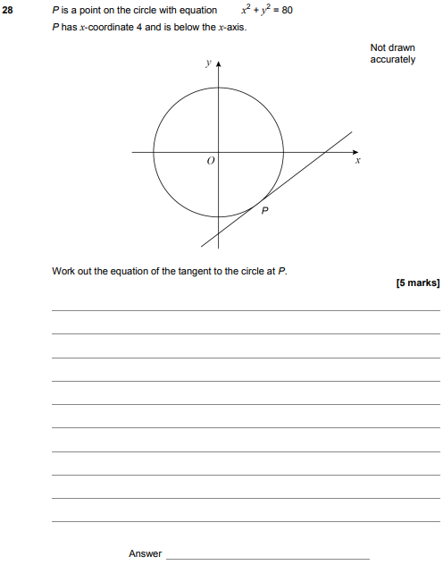

AQA GSCE – Thursday 2 November 2017 – Paper 1 (Non - Calculator) Higher Tier
14.
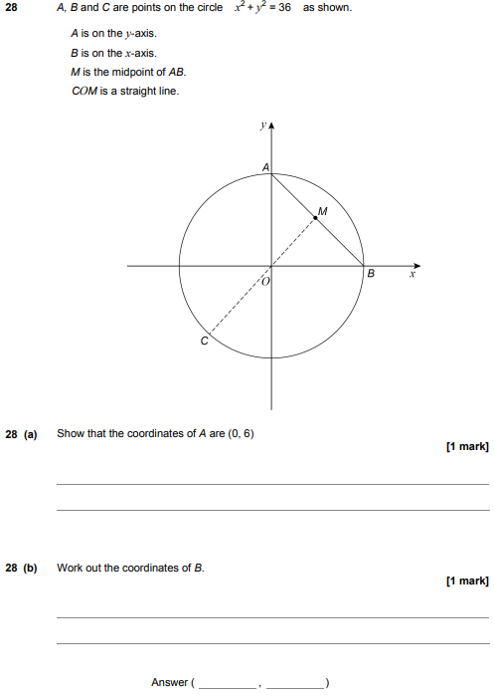

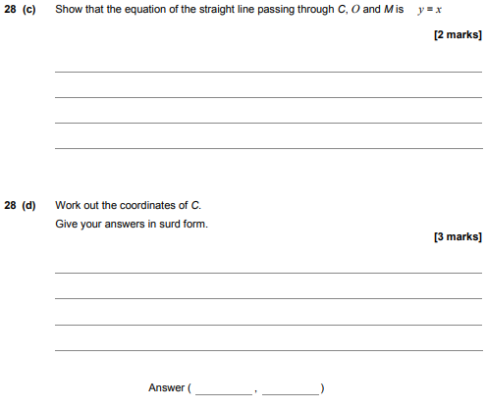

AQA GSCE – Wednesday 25 May 2017 – Paper 1 (Non - Calculator) Higher Tier
15.
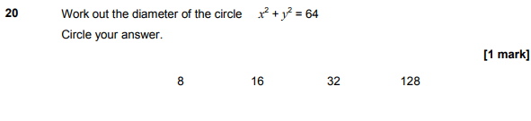
AQA GSCE – Sample Paper 1 (Non - Calculator) Higher Tier
16.
